+++



**Batch: B-2 Roll No.: 16010422234 Experiment No.: 4**

**_____________________________________________________________________________**

# Aim: To create wireframe for Web UI – In Page Editing principle

**_____________________________________________________________________________**

**Resources needed:** Wireframing tool

**_____________________________________________________________________________**

# Theory:

Content on web pages has traditionally been display – only. If something needs editing, a separate form is presented with a series of input fields and a button to submit the change.

# In–Page Editing:

There are six patterns that define the most common in-page editing techniques: Single-Field Inline Edit: Editing a single line of text

Multi – Field Inline Edit: Editing more complex information

Overlay Edit: Editing in an overlay panel

Table Edit: Editing items in a grid

Group Edit: Changing a group of items directly

Module Configuration: Configuring settings on a page directly

The most direct form of In-Page Editing is to edit within the context of the page. First, it means don’t leave the page. Second, do the editing directly on the page.

# Single – Field Inline Edit

The simplest type of In – Page Editing is when editing a single field of text inline. The editing happens in place instead of in a separate window or on a separate page.

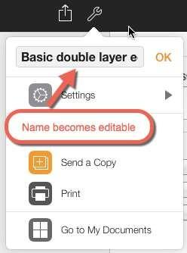

Figure 1 shows principle of Single-Field Inline Edit Challenges associated with Single-Field Inline Edit

* Discoverability
* Accessibility

**Multi – Field Inline Edit**

The pattern Multi – Field Inline Edit describes: editing multiple values inline. The simplest example of the same is form.

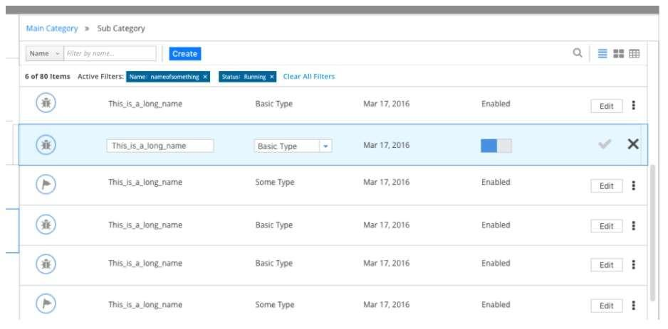

Figure 2 shows principle of Multi-Field Inline Edit

# Overlay Edit

Overlay Edit patterns bring the editing form just a layer above the page. While still not leaving the page for editing, it does not attempt to do the editing directly in the flow of the page. Instead a lightweight pop-up layer (e.g., dialog) is used for the editing pane.

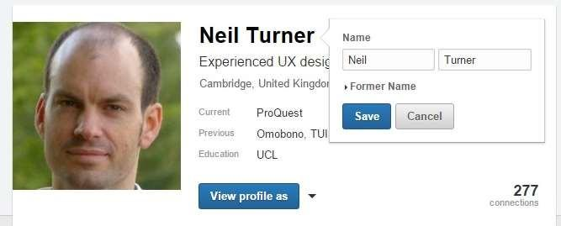

Figure 3 shows principle of Overlay Edit

In the LinkedIn page, rather than the usual design pattern of bringing up an overlay to allow users to edit a field a user can click on the field to edit it within the page.

**Table Edit**

Editing tables of data is less common in consumer web applications but in enterprise web applications, however, tables reign supreme. The most common request is for table editing to work like Microsoft Excel, which long ago set the standard for editing data in a grid. A good example of Table Edit is a Google Docs Spreadsheet.

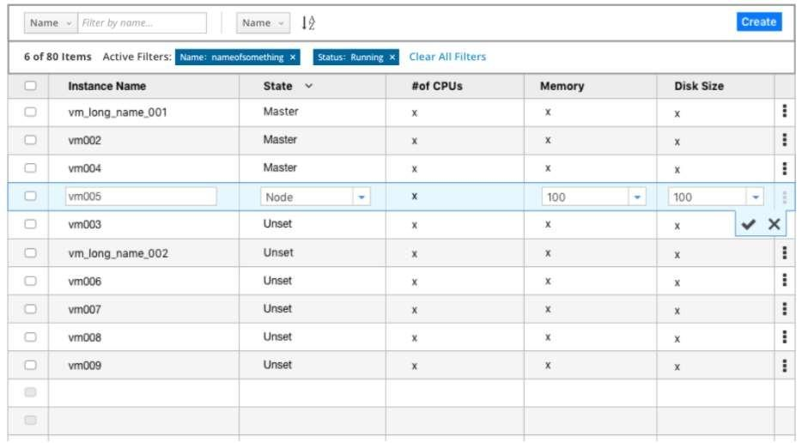

Figure 4 shows principle of Table Edit

# Group Edit

To keep the display of items on the page as uncluttered as possible while still supporting editing, consider using a single mechanism to enter a special editing mode: Group Edit.

# Module Configuration

Module Configuration is a common pattern on these types of sites. Instead of modifying modules on a separate page, the sites provide ways to directly configure the amount and type of content that shows in each module.

**_____________________________________________________________________________**

# Procedure:

* Create wireframes incorporating In Page Editing for chosen topics.

**_____________________________________________________________________________**

# Result:

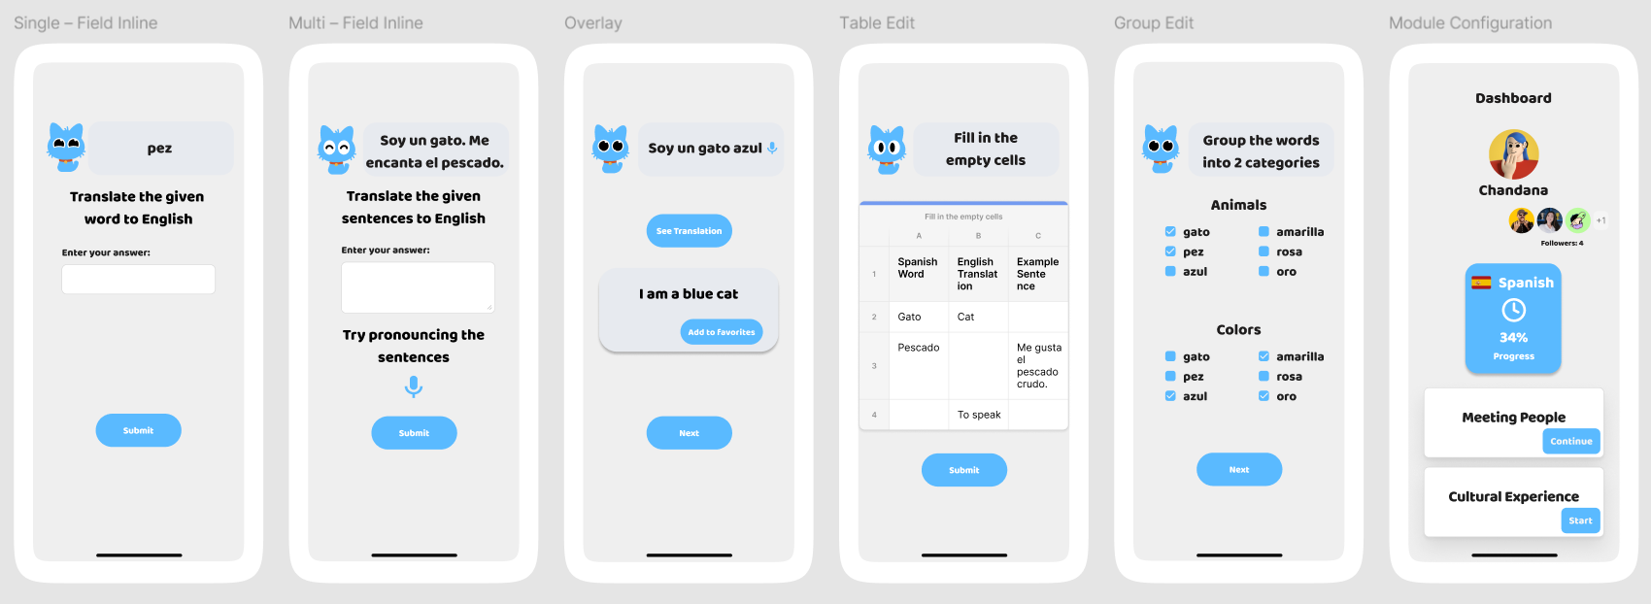

**_____________________________________________________________________________**

**Outcomes: Comprehend the role of user and designer in User Interface Design**

**_____________________________________________________________________________**

# Conclusion: (Conclusion to be based on the objectives and outcomes achieved)

In this experiment, we successfully illustrated various In-Page Editing techniques through wireframes, highlighting how each method enhances user interaction by allowing direct content modification on the page. By incorporating Single-Field patterns, we have demonstrated practical applications that improve user efficiency and streamline content management, ultimately contributing to a more intuitive and user-friendly web interface design.

**_____________________________________________________________________________**

**Grade: AA / AB / BB / BC / CC / CD /DD**

# Signature of faculty in-charge with date

**_____________________________________________________________________________**

**References:**

1. Wilbert O. Galitz, “The Essential Guide to User Interface Design - An Introduction to GUI Design Principles and Techniques”, Wiley Computer Publishing, Second Edition, 2002
2. Bill Scott, Theresa Neil, “Designing Web Interfaces Principles & Patterns for Rich Interaction”, O’rielly Media, First Edition, 2009

**_____________________________________________________________________________**